Tiffin University

SWOT/PEST Analysis

SRM537
Personnel Management In Sports
Dr. Bonnie Tiell

Jessica Hoert

Delaware, Ohio

May 20, 2012

Introduction: Recreation Services of Delaware

The city of Delaware, Ohio recently partnered with the Central Ohio YMCA and the Ohio Army National Guard to build a brand new 72,300 square-foot facility that opened in November 2011. The Delaware YMCA Community Center includes a fitness center, multipurpose gym, two pools, group exercise studios and athletic fields. In 2013 the Ohio National Guard will build a 65,000 square-foot training facility adjacent to the Community Center.

The partnership has been rendered more unique by the City of Delaware voting to allow the YMCA to begin managing the city’s Parks and Recreation program starting in January 2012. As a progressive cost-saving initiative, this combined “public-private partnership is estimated to save the city around $70,000 per year” (staff, 2011). The agreement allows the YMCA to manage the city’s recreation programming and operations at Mingo Park, the city’s athletic park and pool. The City of Delaware and the YMCA have appointed Paul Weber as Director of City Recreation Services and Dawn Patterson as Senior Program Director for operations at Mingo Park and the YMCA (YMCA of Central Ohio, 2011).

The newly appointed Recreation Services of Delaware started limited programs in January of 2012 and now has a large selection of recreational and sports opportunities for Delaware county residents. The new and expanded list of programs offers even more activities for adults and children. The coordinated efforts between the city and the YMCA are being closely monitored to review the success of the partnership. There are several other cities throughout the United States that are choosing the same cost saving initiatives, including the city of Holly Hill, FL.

SWOT Analysis
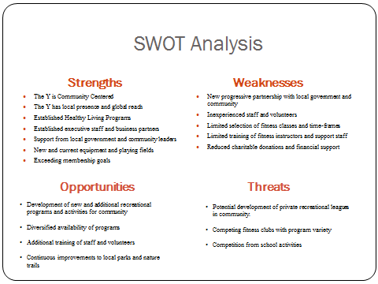

PEST Analysis
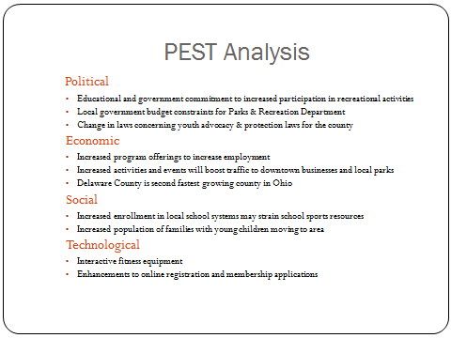

Employment Related Strategies

The unique partnership between the City of Delaware, the YMCA and the Ohio Army National Guard leaves open endless possibilities for future program expansions for Recreation Services of Delaware. The county of Delaware had a population increase of 58.4% between 2000 and 2010 and is still on track for continued growth (Bureau, 2012). Strategically, it would be best for Recreation Services of Delaware to capitalize on the population increase and continue to offer new and expanded program and sports opportunities for the community.

There is also an opportunity at the YMCA Community Center to offer an enhanced selection of fitness programs and equipment to appeal to young professionals with families moving into the area. According to 2010 Census data, the median household income in Delaware County was $87,908 and the median home price was $252,700, well above the State averages (Bureau, 2012). With more disposable income available, families will be looking for more programs and classes to choose from and will be willing to pay for them.

These two organizational strategies will require an increase in the staff relative to the program enhancements and changes. The staffing goals comparative to each strategic initiative are:

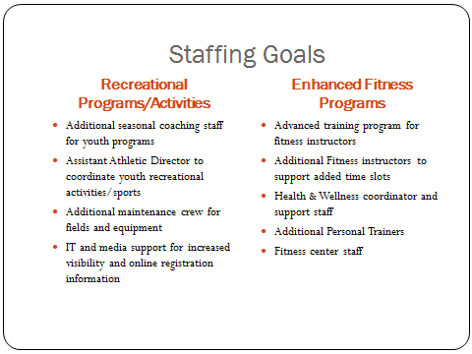

Action Plans

Based on a three year employment plan for expanded programming and sports opportunities, it will be ideal to break down the staffing goals by season. Currently, the youth programs are staffed by volunteer coaches and referees. Increased participation will lead to an increased number of teams. The first season will add an Assistant Athletic Director who will be responsible for securing the volunteer staff. The increased use of the fields and grounds will require more maintenance personnel for up-keep. The Director of City Recreation Services will be responsible for the additional maintenance staff at a rate of one person for every two seasons. Mr. Weber will also be responsible for staffing one IT and one media support personnel to assist with increased registration demands.

The employment plan for enhanced fitness programs will be based on new membership enrollment numbers. The Health and Wellness Coordinator will be responsible for monitoring the influx of new members at the Community Center. Winter programs will see an increase in participation and will require an additional three to five fitness instructors to accommodate the class schedule. An added training program will provide certification on location for the fitness instructors seeking additional training. Every 100 new enrollments will require an additional personal trainer on-site and two fitness center staff members.

Conclusion

Recreation Services of Delaware has been able to successfully merge the old Parks and Recreation Programs with new YMCA programs and activities. The new Delaware Community Center has also surpassed pre-opening goals for new membership and fitness classes. With the sustained population growth in Delaware County, Recreation Services of Delaware will continue to see its participation rates increase. The strategic goals of the organization will focus on increased program participation over the next three years. The staffing goals and action plans are designed to meet the outlined strategic initiatives for the organization.

Works Cited

Bureau, U. C. (2012, January 31). State & County QuickFacts. Retrieved from U.S. Census Bureau: http://quickfacts.census.gov/qfd/states/39/39041.html
Carloss, T. (2011, April 20). Northeast Ohio county ranks in the top 10 for growth. Retrieved from Newsnet5.com: http://www.newsnet5.com/dpp/news/local_news/only-one-northeast-ohio-county-ranks-in-the-top-10-for-growth
staff, C. I. (2011, April 21). Y May Take Over Ohio City's Rec Programming. Retrieved from Club Industry.com: http://clubindustry.com/nonprofits/ymca-city-recreation-merger-possible-20110421/
YMCA of Central Ohio. (2011). Recreation Services of Delaware. Retrieved from YMCA of Central Ohio: http://www.ymcacolumbus.org/recreation

